World PH Day 2026 – Posting Plan
“HOPE IN EVERY TRIAL”

DATE | FORMAT | COPY/text with hashtags | VISUAL to be published
30th of April |  | #HopeInEveryTrial #WorldPHDay2026  𝗪𝗼𝗿𝗹𝗱 𝗣𝘂𝗹𝗺𝗼𝗻𝗮𝗿𝘆 𝗛𝘆𝗽𝗲𝗿𝘁𝗲𝗻𝘀𝗶𝗼𝗻 𝗗𝗮𝘆 𝟮𝟬𝟮𝟲 puts an emphasis on a theme that brings hope to the pulmonary hypertension community. Under the theme Hope in Every Trial, we shine a light on the life-changing impact of clinical trials and research.  Through patient testimonials, from those who have participated in clinical trials to those advocating for better access and availability, we amplify the voices driving progress and highlight the growing need for more clinical trials worldwide, especially in developing countries.  Join us in marking World Pulmonary Hypertension Day on May 5, and throughout the month, as we explore the importance of clinical trials and patient contributions in advancing care.  PHAEUROPE stands with the global PH community. | 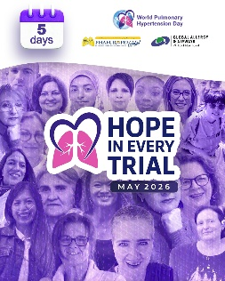  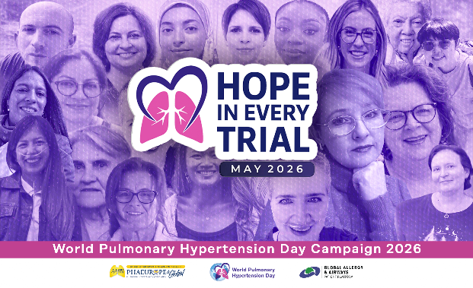
1st of May | ONLY PHAE | This year, the World PH Day toolkit gives you everything you need to adapt, translate, and share ready-to-use materials to raise awareness of pulmonary hypertension.  Explore and customize our infographics, informational posts, and patient testimonials. Each resource is designed to be easily translated and adapted, helping you spread awareness in your own language and within your community.  From every corner of the world, patient stories come together to highlight this year’s theme—clinical trials—and the vital role research plays in transforming care through innovative treatments. At the heart of it all are patients, whose voices and experiences drive progress forward.  On May 5, and throughout the campaign, we stand united—empowering patients, caregivers, and the entire PH community to raise their voices.  Find the toolkit here: www.worldphday.org  and follow our pages. | 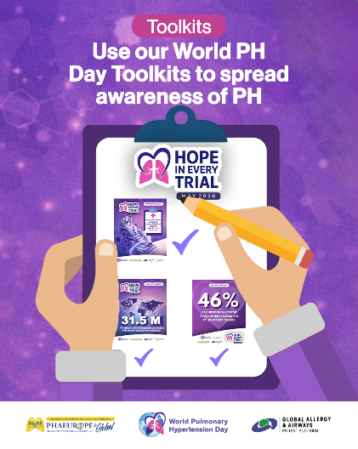
4th of May |  | Tomorrow, we mark World Pulmonary Hypertension Day.  But for those living with this chronic and progressive disease, pulmonary hypertension (PH) is not just one day - it is every day.  PH is a general term for five groups defined by the World Health Organization, each with similar life-limiting symptoms, yet differing in cause, complexity, and severity. Despite significant progress in research, medical innovation, and novel therapies over the past 25 years, PH remains incurable and many challenges persist.  What must not be overlooked is its invisibility.  Too often, people living with PH appear “fine” on the outside — leading to delayed diagnoses, frequent misdiagnoses, and barriers to timely care. This invisibility has real consequences, impacting both outcomes and quality of life.  On this day, and every day, we stand with the PH community in their call for:  - timely diagnosis,  - equitable access to care and clinical trials,  - improved quality of life,  - improved patient involvement in care  - and continued innovation toward a cure.  Because behind every diagnosis, there is a life — and with every challenge and trial, there is hope. | 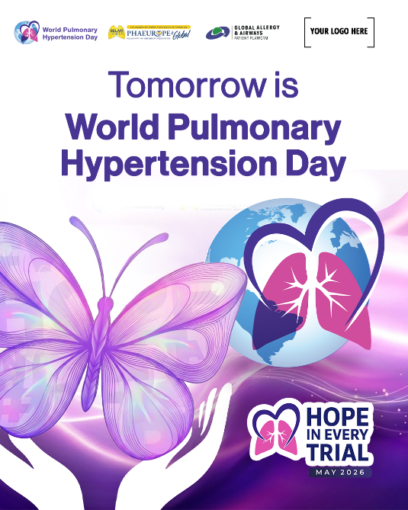
5th of May |  | Today is World Pulmonary Hypertension Day!  Observed globally on May 5 and spearheaded by PHAEUROPE, the umbrella association uniting European and global PH patient organizations, this day brings together PH voices into one powerful movement.  Join us today, and throughout May, by sharing our informational posts and patient testimonials. Use our toolkits to translate these materials and stories into your own languages, bringing the experiences of people living with PH closer to your community.  This year’s theme, “Hope in Every Trial,” reflects the dual meaning of the word trial: the daily challenges faced by PH patients, and the vital role of clinical trials in advancing innovative, more effective therapies. This year we raise awareness of PH and advocate for more inclusive clinical trials across the globe.  It is PH patients, through their courage, participation, and lived experience, who help drive progress in treatment and care along with PH exerts, researchers, clinicians, carers, scientists… By sharing personal stories and experiences with clinical trials, this year’s campaign highlights that every patient plays a crucial part.  Because in every challenge, there is strength — and in every trial, there is hope. | 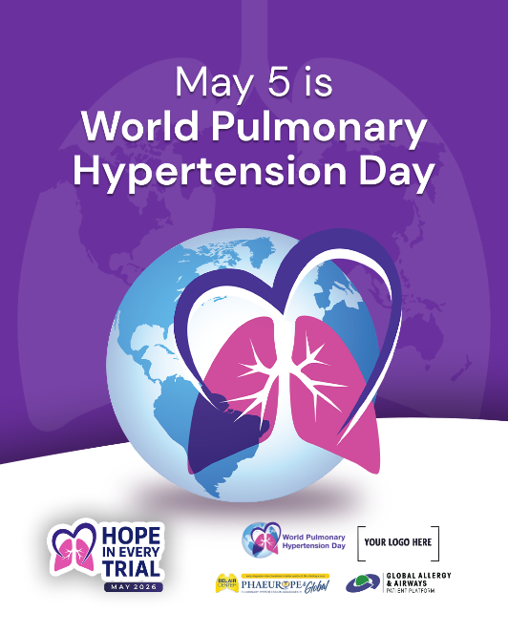
6th of May |  | Pulmonary hypertension (PH) is a life-threatening condition in which high pressure in the arteries of the lungs places strain on the right side of the heart.  There are five groups of PH, each with different causes, prevalence, and severity. Despite these differences, all forms of PH are complex and remain difficult to diagnose, treat, and manage. PH often occurs alongside other heart, lung, or systemic conditions.  Early diagnosis and timely access to care and treatment are essential for improving outcomes and quality of life. Modern combination therapies, supplemental oxygen, infusion pumps, and holistic care can help manage symptoms of this chronic, lifelong condition. Without proper management, PH can lead to severe, life-threatening complications such as right heart failure or even death.  Each patient is different, with symptoms varying in severity and impact, which is why treatment approaches should be individually tailored. Limited awareness, restricted access to innovative therapies, clinical trials, and gaps in understanding among both the public and healthcare systems remain key barriers to better outcomes and better quality of life.  Learn more about the work of PHAEUROPE, the European umbrella organization, and how it is improving the lives of people living with PH across Europe and globally. | 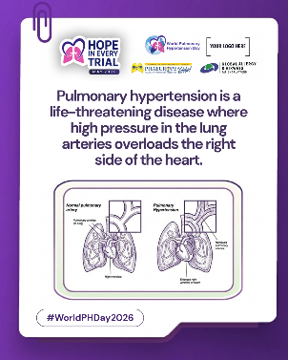  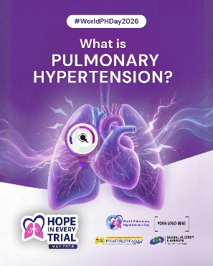
7th of May |  | Know the symptoms! The most common symptoms of pulmonary hypertension are shortness of breath and fatigue.  Other symptoms may include:  - Shortness of breath  - Excessive tiredness or fatigue  - Chest pain  - Swelling  - Fainting or near-fainting episodes (syncope)  - Palpitations (a racing, thumping, or fluttering feeling in the chest)  - Dizziness  - Heart failure  These symptoms can occur both at rest and during physical exertion, and they can have a profound impact on daily life. In many cases, individuals become unable to perform even the simplest everyday tasks. PH symptoms can mimic those of other conditions, which is why specific diagnostic tools are essential. Echocardiography, right heart catheterization, and specialized blood tests must be performed to establish an accurate diagnosis.  PH is triggered by various underlying causes that affect the blood vessels responsible for carrying blood from the heart to the lungs to receive oxygen. As a result, pulmonary hypertension affects the whole body, from the heart and lungs to the brain, largely due to reduced oxygen supply and structural changes in the lung arteries potentially causing other conditions. Without timely diagnosis and appropriate care, this condition can place patients in a very difficult and life-limiting situation. | 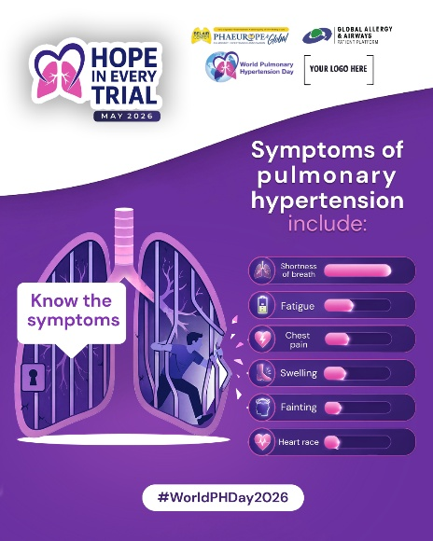
8th of May |  | Małgorzata│ Poland  #HopeInEveryTrial  “Twenty years ago, I said yes to a clinical trial, and I don’t regret it. It wasn’t easy. I traveled 300 kilometers each way, week after week. I underwent countless tests. I lived with uncertainty. But I also experienced something priceless - doctors who had time for me, conversations without time pressure, and, above all, hope. Hope that the medication would work. Hope that I could stop the disease in its tracks and recover. That was priceless.  I have pulmonary arterial hypertension (PAH) as a result of chemotherapy after living with chronic myeloid leukemia for 20 years. I was on triple therapy, but the disease was still progressing. Still, I keep choosing to move forward, because every trial brings hope. Every trial offers a chance for a longer life. Some time ago, clinical trials were launched in Poland, and I qualified for one.  I believe everyone should have access to clinical trials. And I would participate again without hesitation.”  — Małgorzata Piekarska, Poland 💙  This World Pulmonary Hypertension Day, we are honoring the courage of patients like Małgorzata, who don't just face their illness, but help shape the future of treatment for all of us. Real progress begins with patients. 💙 | 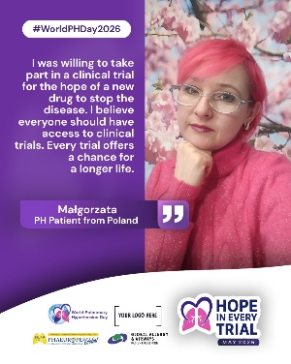  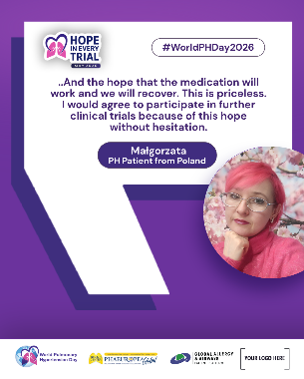
8th of May |  | Barbara│ Poland  #HopeInEveryTrial  “My name is Barbara Malinowska, and I have had Pulmonary Arterial Hypertension since 2020. My condition kept getting worse. I went from pills to pumps, from small to large, and eventually I was qualified for a lung transplant. That was a tough time.  Then Professor Grzegorz Kopeć from Krakow offered me the chance to join a clinical trial for a new medicine, something not yet available on the market, meant to keep my condition stable until the transplant. I was one of the first people in Poland to receive it.  The trial was at John Paul II Hospital in Krakow, the only hospital in Poland running clinical trials non-stop. They thought of everything. I live 70 km from Krakow, so a taxi would pick me up right at my door, take me to the hospital, and bring me back. Everything was tailored to my needs. Everything was patient-friendly, from the very first visit to the very last.  Today, I am two years post-lung transplant and I am feeling good.  Joining that trial gave me quick access to a treatment that was not yet available anywhere else. It gave me stability. It gave me time. It gave me a new quality of life. The medicines being tested in clinical trials are not just new treatments. They can save lives. Mine is proof of that.  If you are dealing with a serious illness, please talk to your doctor about clinical trials. For me, it was hope. And hope changed everything."  — Barbara Malinowska, Poland 💙 | 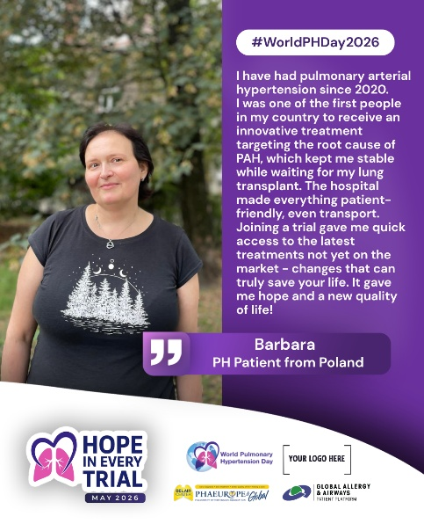
9th of May |  | Pulmonary hypertension (PH) is not a single condition, but a group of five distinct conditions, each with different causes, mechanisms, and clinical profiles. Understanding these groups is essential for accurate diagnosis and tailored treatment.  Group 1: Pulmonary Arterial Hypertension (PAH)  Caused by narrowing, stiffness, or scarring of the small pulmonary arteries, often linked to genetic factors, autoimmune diseases, or certain drugs.  Group 2: PH due to Left Heart Disease  The most common form in adults. It develops when the left side of the heart cannot pump effectively, causing pressure to back up into the lungs.  Group 3: PH due to Chronic Lung Disease or Hypoxia  Associated with long-term lung conditions such as COPD or interstitial lung disease, where low oxygen levels and lung damage lead to increased pulmonary pressure.  Group 4: Chronic Thromboembolic Pulmonary Hypertension (CTEPH)  Caused by unresolved blood clots that obstruct pulmonary arteries. Unlike other forms, it can sometimes be treated surgically.  Group 5: PH with Multifactorial or Unclear Mechanisms  A heterogeneous group where the exact cause is not fully understood, often involving complex systemic or hematologic conditions.  Together, these five groups highlight the complexity of pulmonary hypertension and underline the importance of precise diagnosis to ensure appropriate care and treatment. | 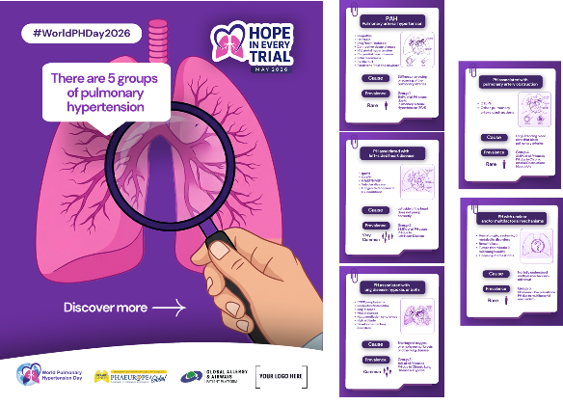
11th of May |  | Pulmonary hypertension affects an estimated 31.5 million people worldwide, with an even greater societal impact on patients, families, and healthcare systems.  Beyond the numbers lies a broader reality. PH affects every aspect of life, from physical ability and mental wellbeing to social and economic participation. Its burden extends far beyond the individual, shaping families, caregivers, and society as a whole.  Some global estimates suggest that up to around 1% of the general population may be affected by pulmonary hypertension. In older adults, particularly those over 65 years of age, prevalence may be higher, reaching up to around 10%, largely due to more common underlying heart and lung diseases.  Among the five groups of PH, three are considered rare, while PH due to left heart disease and PH associated with chronic lung disease are significantly more common. | 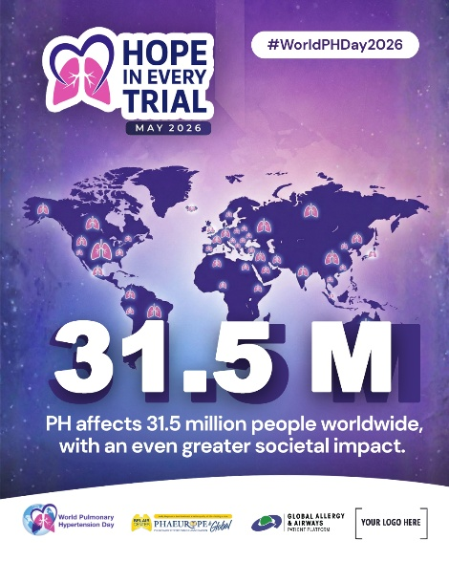
12th of May |  | Ayotunde│ Nigeri  #HopeInEveryTrial  "Africa is home to about 20% of the world's population, yet only about 3% of global clinical trials happen here. In pulmonary hypertension, it is even more limited, with most research on the continent taking place in South Africa. As someone living with pulmonary hypertension in Nigeria, I have never had the opportunity to participate in a clinical trial.  The causes of pulmonary hypertension here often differ from those in high-income countries. Conditions like sickle cell disease, HIV, congenital heart disease, schistosomiasis, and rheumatic heart disease play a major role in our communities. These realities are still underrepresented in global research.  When I read about clinical trials, new treatments, and promising results, there is a quiet awareness that we are not yet included in the story. That patients like me are still waiting at the door of progress.  But I hold on to hope. Because the future I believe in is one where every patient, regardless of where they live, is included in clinical trials, represented in the data, and able to share in the breakthroughs that can save lives. That future is worth fighting for. And I truly believe it is coming."  — Ayotunde, Nigeria 💙 | 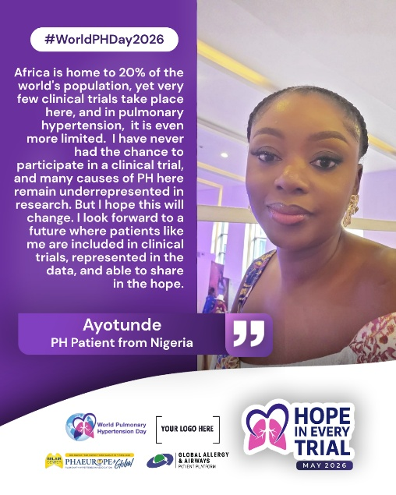
12th of May | International  Nurses  Day  ONLY PHAE | This International Nurses Day, we celebrate the heartbeat of pulmonary hypertension care, our nurses.  In the spirit of this year’s World PH Day theme, “Hope in Every Trial,” we recognize nurses as an essential part of every step forward in PH care and research.  From performing diagnostic tests and monitoring patients, to administering therapies and supporting participation in clinical trials, nurses are present in every moment that shapes progress. They are not only caregivers at the bedside, but also key contributors to advancing knowledge and improving outcomes.  To every nurse supporting people living with PH, your expertise, compassion, and dedication turn complex clinical journeys into pathways of hope. You help bridge science and care, ensuring that innovation reaches the people who need it most.  You are part of every trial, every treatment, and every step toward better care. And in that, you bring hope. Thank you! | 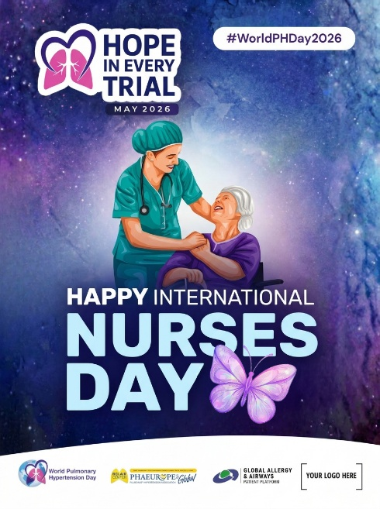
13th of May |  | Bendjaada │ Algeria  #HopeInEveryTrial  "My name is Bendjaada Rim, and I am 22 years old, living with a very rare form of pulmonary hypertension called PVOD. I was diagnosed at the age of 12 in Algeria, when my world changed completely. What began as extreme fatigue, shortness of breath, and a racing heart eventually led to a diagnosis that shook my entire family. As a child, I could not fully grasp what I was facing. But I grew into it, and it grew into me.  Living with this condition in Algeria means navigating a reality that many in the global PH community may not see. Out of more than 14 treatments available worldwide, only two are accessible in my country. Many patients are diagnosed at advanced stages because the disease is still not widely recognized within our healthcare system. Clinical trials, which represent hope and progress for so many, remain largely out of reach for patients like me. Furthermore, my condition belongs to Group 1 PVOD, which makes participation in clinical trials particularly complex.  My own experience with a new treatment was not part of a formal clinical trial, but it carried the same weight. My condition had moved beyond stability, and I had to take a step into the unknown. Fortunately, I responded well, and I regained a degree of stability I had not felt in a long time.  That experience made one thing clear to me: access to new treatments is not a privilege. It is something every patient deserves, regardless of where they live. Access to innovative treatment means life for us.  Today, I am a university student, close to graduating. I have written a book about my journey, titled “The Killer Friend”, because this illness is painful, yet transformative. I advocate every day for recognition, for access, and for the voices of patients like me to be heard in global research and decision-making. On a positive note, today, specialists in Algeria are working hard to push for the official recognition of this disease and to improve access to therapies.  We are here. We deserve to be included. And I truly believe that one day, we will be.  I share my story, I raise awareness, and I affirm every single day that patients like me deserve to have their voices heard in healthcare decisions, in research, and in global conversations about the future of this disease. We are not on the margins of this story. We are at its heart.  — Bendjaada Rim, Algeria 💙 | 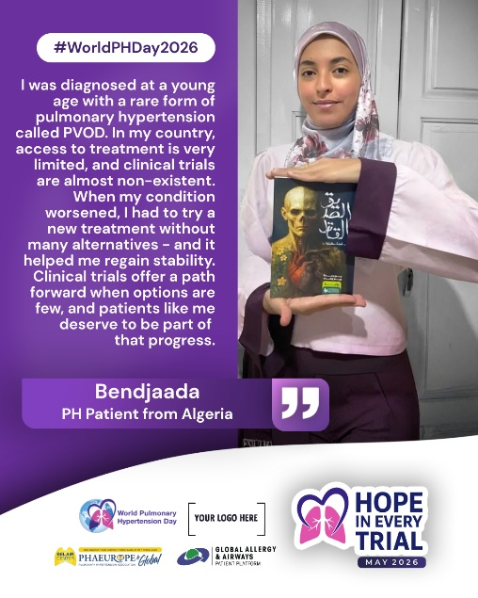
13th of May |  | Pulmonary hypertension often begins with symptoms that seem common — shortness of breath, fatigue, reduced exercise tolerance—and are easily attributed to other conditions.  On average, it still takes 2–3 years and at least 3 different doctors before PH is correctly identified. During this time, patients are often treated for other suspected causes while the disease continues to progress.  Because there is no simple routine screening and symptoms are non-specific, PH is frequently recognized only after significant delay, when the condition is already advanced (in almost 75% of cases).  Earlier suspicion and referral to the specialized PH centers in anyone with unexplained heart-lung symptoms can shorten this journey.  Time matters in pulmonary hypertension. | 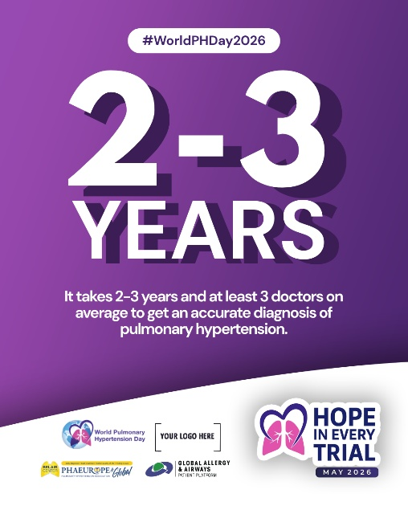
14th of May |  | Pulmonary hypertension (PH) is the unseen pressure.  It cannot be seen from the outside, yet it weighs heavily within. Behind a “healthy” appearance, people living with PH face breathlessness, exhaustion, and limits that are too often misunderstood or overlooked.  But the pressure goes beyond symptoms. It is shaped by delayed recognition, limited awareness, and the lack of understanding and support along the way.  PH is not visible on the surface.  It is heard in difficult breaths, seen in blue lips, felt in constant fatigue—and in the silent weight of pain that often remains unseen.  Look below the surface.  The reality of PH is real. The need for understanding and support is real. | 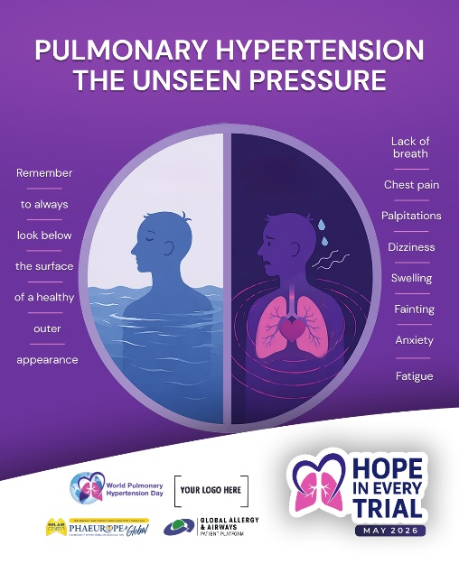
14th of May |  | Luz │ Venezuela  #HopeInEveryTrial  "My name is Luz Osorio. I am 32 years old, a physiotherapist, and I have been living with pulmonary hypertension for 11 years. I am Venezuelan. And like many patients, my story is not only about a disease. It is about everything we have had to go through just to be able to live.  When I was first diagnosed, I was told I had idiopathic pulmonary hypertension. It was only after leaving my country that I received a more precise diagnosis: a congenital heart disease associated with Eisenmenger syndrome. That change was not a coincidence. It was access. Access to tests, to specialists, to opportunities I simply did not have in Venezuela.  In Venezuela, treatment options are very limited. In many cases, only one therapy is available, and even that is not guaranteed continuously. Patients deteriorate every day, losing not only their health but also their hope. The advances that are changing the course of pulmonary hypertension around the world, treatments proven in clinical trials to improve lives, do not reach everyone. And that is why I had to migrate.  Today I live in Colombia, where I have been able to access triple therapy and regain stability. But my condition has progressed, and I have already been told about the possibility of a heart-lung or double lung transplant with correction of the congenital defect. A highly complex surgery that, in my environment, still does not have favorable outcomes.  My story is not unique. It is the voice of many patients in Venezuela and across Latin America who do not have access to timely diagnoses, appropriate treatments, or clinical trials.  It is not fair that we have to leave our country just to have a chance to live.  We need access. We need equity. We need innovation to reach those who need it most. Today I raise my voice, not only for myself, but for all those who are still waiting."  — Luz Osorio, Venezuela/Colombia 💙 | 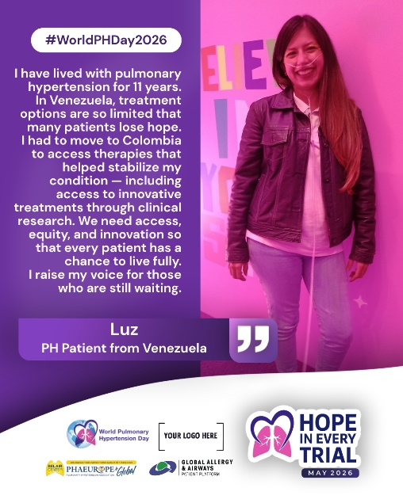
15th of May |  | Every clinical trial is a step forward.  Every step strengthens what comes next.  Every trial brings us closer to better treatments for pulmonary hypertension.  Clinical trials in PH are actively exploring new therapies designed to target the underlying disease mechanisms - aiming not only to manage symptoms, but to slow, halt, or even reverse vascular remodeling and disease progression.  For many people living with pulmonary hypertension, current therapies (combination therapies) improve quality of life, exercise capacity (6-minute walk test), and important biomarkers such as NT-proBNP - but they do not yet offer enough control over the disease burden or long-term outcomes for a significant percentage of patients in high-risk group.  That is why research matters.  Today’s clinical trials often build on existing standard-of-care treatments, testing new medicines on top of what patients are already receiving. This reflects both scientific progress and clinical reality — many participants are already on combination therapies.  Ongoing studies are especially focused on Group 1 (PAH) and Group 3 PH, with increasing emphasis on meaningful outcomes: survival, functional capacity, disease progression, and quality of life — not just numbers, but lived experience.  Clinical trials are not just research.  They are opportunity, contribution, and progress.  For people living with PH, they offer a way to help drive innovation forward — and to shape the future of treatment for everyone still waiting for better options. | 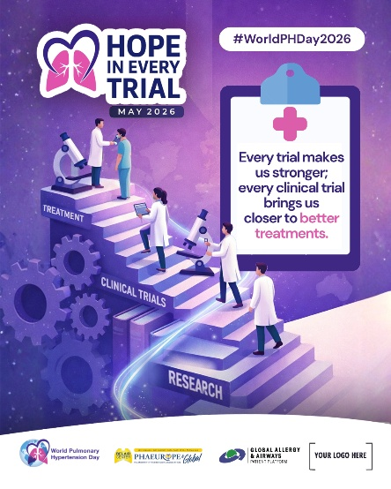  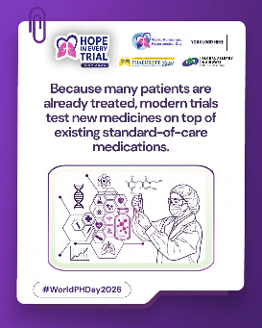  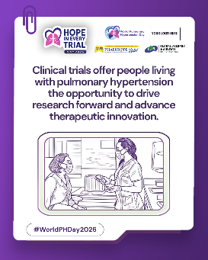
16th of May |  | Jeannie │ Canada  #HopeInEveryTrial  "My name is Jeannie, and I live in Canada with pulmonary hypertension and pulmonary fibrosis, secondary to scleroderma. Today, there is no approved therapy in Canada specifically for people living with PH-ILD, particularly where there is extensive fibrosis in the lungs. That gap is real, and it affects so many of us.  That is why I chose to enroll in a clinical study. I believe that through my participation, researchers can gain meaningful information from my consultations, lab tests, imaging, procedures, and health questionnaires. Every monthly study day, every weekly call from the research coordinators checking on how I feel, every reading logged into the system — it all contributes to something larger than me.  What has moved me most is how the study team approaches participation. They allow time to make informed decisions. They ask every single time whether I wish to proceed. That respect for the patient's voice is not a small thing. It is everything.  My hope is that one day, a new inhaled therapy, taken just once daily, will be available for people living with PH-ILD. Inhaled therapies go directly to the lungs, which could make a real difference for patients who struggle with the side effects of oral medications, especially when they are taking so many pills with associated conditions like me.  There is no current treatment for people like me in Canada. But there is research. And as long as there is research, there is hope."  — Jeannie, Canada 💙 | 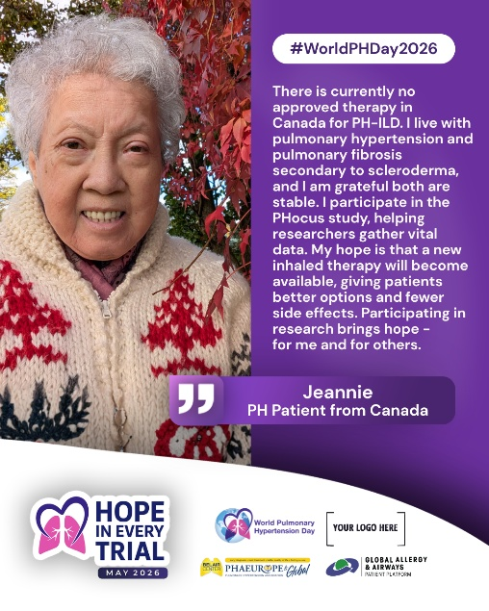
16th of May |  | Pulmonary hypertension (PH) linked to left heart disease is the most common form of PH worldwide.  - 30–60% of people with left heart disease (heart failure or valvular disease) may develop PH  - 2021–2023 estimates: 55–64 million people live with heart failure globally  This makes PH in left heart disease the most frequent clinical context in which PH occurs  In Group 2 PH, the origin is the left side of the heart. When it cannot pump efficiently, pressure backs up into the lungs, increasing strain on the pulmonary circulation and eventually affecting the right heart.  The symptoms of PH often overlap with those of left heart disease, making it harder to distinguish and diagnose. Despite its prevalence, it remains under-recognized.  Behind millions of heart failure cases, PH is frequently already present — silently influencing disease progression and making treatment more complex.  Beyond PH caused by left heart disease, up to 10% of patients with chronic heart disease, including congenital heart diseases, develop clinically significant pulmonary hypertension.  Recognizing the signs early is essential to support timely diagnosis and optimize treatment outcomes. | 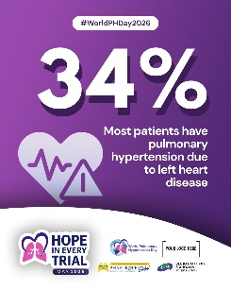  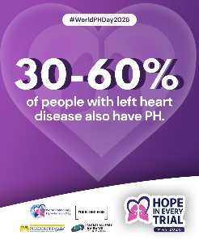
18th of May |  | Females are 2–3 times more likely to develop pulmonary arterial hypertension (PAH) than males. Yet almost 46% of PAH cases remain without a known cause – known as idiopathic PAH.  This is not just a difference in numbers. It is a difference in visibility, recognition, and time to diagnosis.  PAH in women often begins quietly:  • fatigue that is explained away as stress or overwork  • breathlessness that is normalized as “being out of shape”  • dizziness that is minimized or overlooked  Gradually, these signs stop blending into everyday life - and start taking it over.  PAH does not choose gender. But it does not affect everyone the same way. In women, it is more often missed, delayed, or misunderstood — allowing the disease to progress silently while life continues on the surface.  Pulmonary Arterial Hypertension (PAH) is a severe, progressive, and life-threatening condition. It places increasing strain on the right side of the heart and, without treatment, can lead to right heart failure and premature death.  Modern therapies and combination treatments have improved outcomes significantly, with many patients now living longer than before. But PAH remains a chronic condition requiring early detection, continuous care, and lifelong management. | 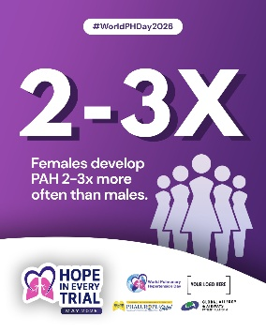  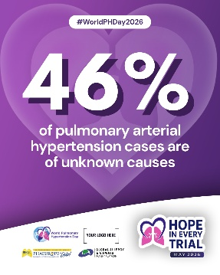
18th of May |  | Damaris │ Mexico  #HopeInEveryTrial  "My name is Damaris Salgado Ayala. I am 44 years old, an engineer, and I have been living with idiopathic pulmonary arterial hypertension since 2014. My diagnosis came at 18 weeks pregnant, in an emergency room, coughing up blood and on the verge of losing consciousness, at what should have been one of the happiest moments of my life. The prognosis was critical for both my baby and me.  To survive, I was told there was only one option. On October 2, 2014, my daughter Valentina was born. She did not survive. That pain became the beginning of my fight. In Mexico at that time, only one basic treatment was available for pulmonary hypertension, a reality that unfortunately still persists for many patients today. Against all odds, I survived. Tests confirmed my diagnosis as idiopathic Group 1 PAH, and with that, a door opened: a clinical trial.  Accessing that trial was, for me, an act of faith. I did not fully understand the disease yet, but I knew I wanted to live. I entered a titration protocol, gradually increasing the dose until reaching the optimal level. The side effects were intense and relentless. There were moments when I felt I could not go on. And I remember the words of my doctor, quiet and direct: continue the trial, or there are no other options. I chose to continue. I chose to live.  What followed was years of learning to understand my own body. I tracked my vital signs, identified my triggers, and gradually went from extreme fatigue to walking up to six kilometers in an hour. The side effects are still present every day, but no longer in their harsh form.  That clinical trial was eventually approved. Today I receive the treatment through a compassionate use program, because I was part of the original research. That means something to me that words can barely capture.  Since 2018, I have been an active volunteer in patient associations across Mexico and Latin America (CHPL). I advocate for pulmonary hypertension to be officially recognized as a disabling condition, so that patients can access the rights and support they deserve. People still don’t understand PH and say I look perfectly healthy.  The medication does its job. And I do mine."  — Damaris Salgado Ayala, Mexico 💙 | 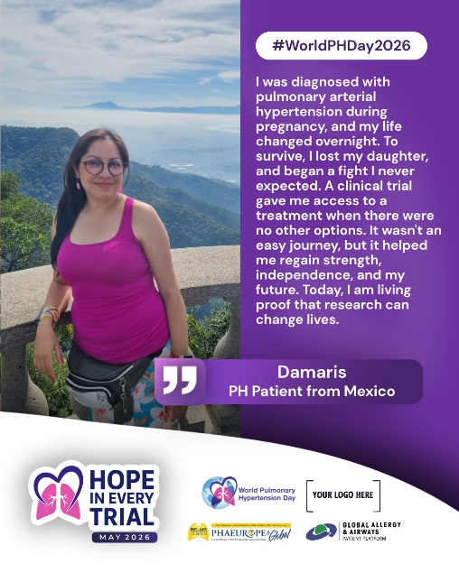
19th of May |  | Daniela │ Germany  #HopeInEveryTrial  "My name is Daniela Schiel. I am 54 years old and have been living with idiopathic pulmonary arterial hypertension for ten years, in Germany. When I was first diagnosed, my condition was so severe that my doctor had already begun discussing a heart and lung transplant. I felt trapped in a black hole. I did not know if there was a way out.  Then I entered a clinical trial. And that changed my life.  I had been put in a wheelchair because my heart was failing. Through the trial, I started a pump therapy that was largely unknown in Germany at the time. And suddenly, I could walk again. First with a walker, then with a cane. Today, I walk on my own.  Living with PH means that oxygen therapy, medication side effects, and physical limitations are part of everyday life. But I have learned to see them differently. Medications are not my enemies. Yes, especially at the beginning, they come with difficult side effects. But if, at the end of that ordeal, I have a better life, or a life at all, then it is worth going through that uncomfortable tunnel. Make your medications your friends, just like the oxygen therapy, the central venous line, and the pump bag. We are incredibly adaptable as human beings. Even the most foreign things eventually become part of who you are.  I also know that without research, many patients today would have no treatment options at all. Clinical trials are not something to turn away from. You are not just giving something. You are receiving too. You are monitored closely, examined carefully, and given attention that genuinely matters.  My message to anyone who hesitates is simple: be curious. A study can be life-changing. Sometimes you have to step out of your comfort zone when it comes to your own life. Inform yourself, ask questions, and have the courage to be part of something greater, for yourself and for every patient who comes after you.  Dum Spiro Spero. While I breathe, I hope."  — Daniela Schiel, Germany 💙 | 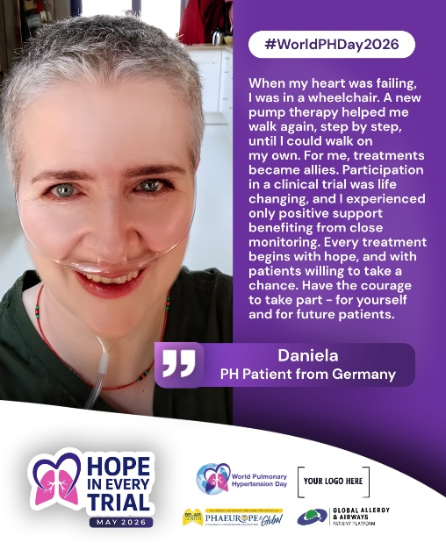
19th of May |  | Modern therapies have dramatically improved life expectancy for people living with pulmonary hypertension (PH) across multiple groups, with ongoing clinical trials and new molecules expanding hope for even more effective treatments in the future.  20 years ago: median survival in PAH was ~2.8 years  Today: median survival exceeds 6+ years — and continues to improve  A few decades ago, effective treatment options for PH were extremely limited. Today, sustained progress in research, clinical trials, and drug development has reshaped the outlook not only for pulmonary arterial hypertension (PAH), but increasingly for other PH groups as well.  Across the PH spectrum, we are now seeing a growing pipeline of innovative therapies and novel mechanisms of action being tested — bringing new possibilities where there were once few.  What were once grim statistics are now evidence of progress in motion. Each clinical trial, each new molecule, and each scientific breakthrough moves us closer to more effective treatment — and closer to hope that one day PH may be better controlled, and ultimately curable.  Research is not just advancing medicine — it is changing lives.  It reminds us that continued investment in science is not optional, but essential. Many patients today receiving modern therapies owe access to these treatments to the previous generation of patients who participated in clinical trials and made progress possible. | 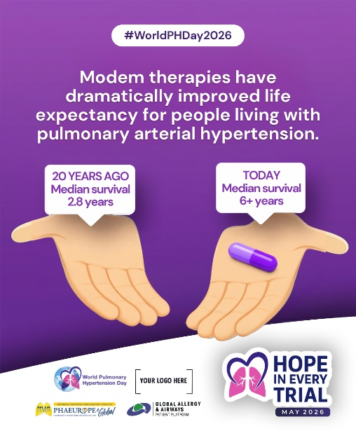
20th of May |  | 🫁75% of patients are diagnosed with progressed pulmonary hypertension (PH), meaning the disease is already advanced at the time of diagnosis, placing patients in a high-risk category.  💔 60–80% of patients experience diagnostic delays of 1 to 4 years from the first symptoms to a confirmed diagnosis.  By that time, PH has often already caused significant and irreversible strain on the heart and lungs.  This is where clinical trials matter. They enable access to novel therapies that can change the trajectory of the disease, especially for patients who currently rely on heart–lung transplantation as their only remaining option.  Many patients who received the most innovative therapies did so thanks to recent clinical trials. For some, these treatments have offered hope, stability, and precious time while waiting for transplantation — in cases where it was otherwise the only available path forward. | 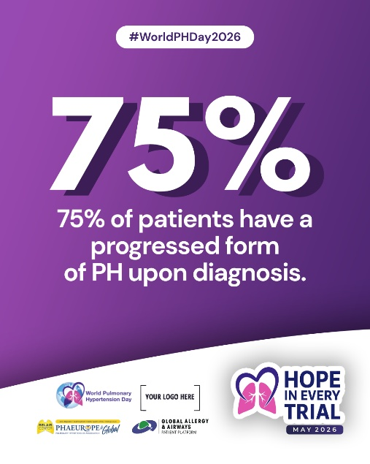
20th of May |  | Denis │ Bosnia and Herzegovina  #HopeInEveryTrial  "My name is Denis Strmota. I am 37 years old, and two years ago I was diagnosed with pulmonary hypertension, although I had been experiencing symptoms for quite some time before that. The shortness of breath during exertion was there, but the diagnosis still came as an unpleasant surprise.  What surprised me even more was the reality I faced at home. In Bosnia and Herzegovina, the treatment of PH patients is almost impossible. I did not receive adequate help in my country. So I made a decision: I would seek treatment in Croatia, where I hold dual citizenship. I was fortunate to be admitted immediately, and after a clinical trial, I was offered an innovative therapy that very quickly resulted in a positive improvement in my health. I experienced a completely different approach. A completely different patient position.  Today, I am satisfied with my condition. But I am not at peace.  The lack of medications in Bosnia and Herzegovina endangers people's lives. I have access to treatments that are simply not available in BiH. And the thought of other PH patients back home, who do not have that access, is frustrating and deeply painful for me.  I will not be fully satisfied until we all have access to the necessary medications. Until proper healthcare is ensured for everyone. Everyone has the right to quality healthcare, regardless of where they live or what their circumstances are. I also believe that more doctors need to be educated about this disease. Many have never even heard of pulmonary hypertension, especially in Bosnia and Herzegovina.  I hope the situation will change soon, thanks to the persistence of the Dah Association and everyone fighting for PH patients in our region. We are not giving up."  — Denis Strmota, Bosnia and Herzegovina/Croatia 💙 | 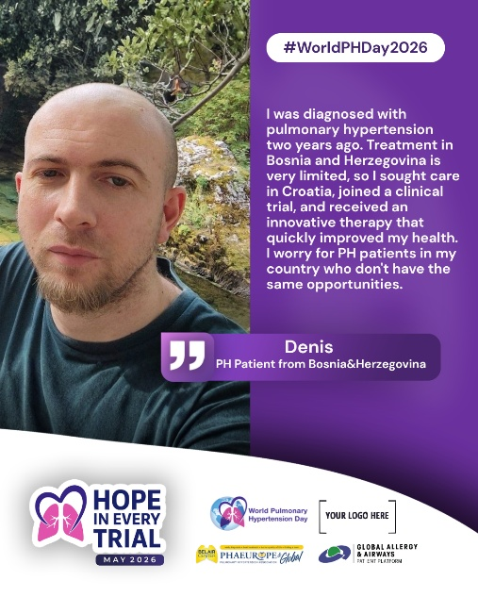
21st of May |  | PULMONARY HYPERTENSION CAN STRIKE ANYONE  regardless of age, sex, race, social, or ethnic background.  Pulmonary hypertension (PH) does not discriminate. It can affect anyone, from children to adults, often silently progressing while being mistaken for more common conditions such as asthma or COPD. This is one of the key reasons why PH is frequently misdiagnosed and diagnosed too late.  Early symptoms like breathlessness, fatigue, dizziness, or chest discomfort are often subtle and easily overlooked especially in female and pediatric population. But behind these signs, PH may already be placing a dangerous strain on the heart and lungs.  In children, PH is rare but serious:  Incidence: estimated at 4–10 cases per million children per year  Prevalence: ranges between 20–40 cases per million children  However, these figures mainly reflect data from well-resourced healthcare systems. Reliable epidemiological data from developing countries is still largely missing, meaning the true global burden of pediatric PH remains underrecognized and underestimated.  Children with PH can present at any age and with varying severity and associated conditions. Over the past decades, outcomes have improved thanks to advances in PH-specific therapies. However, pediatric PH remains significantly under-researched. There is still a critical need for well-funded clinical studies to better understand disease progression, identify risk factors, and optimize treatment strategies tailored specifically for children. | 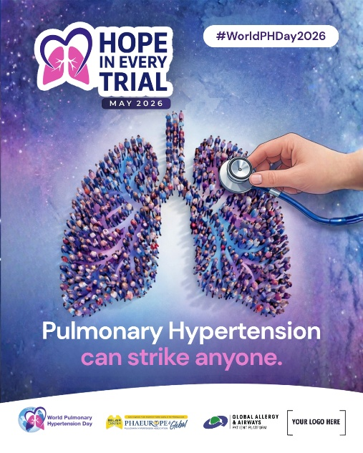
21st of May |  | Natalia │ Argentina  #HopeInEveryTrial  "My name is Natalia. I live in Córdoba, Argentina. I have been married for 17 years, I have two children, and ten years ago I was diagnosed with Pulmonary Hypertension.  When my doctor suggested I participate in a clinical trial for a new medication, I accepted without hesitation. I trusted him completely. But there was something deeper behind my decision too. Since my disease is congenital, I immediately thought about my children and my family. I felt I was also doing it for them. And later, over time, I understood that I was doing it for all patients worldwide.  I didn't know whether I was receiving the medication or a placebo. But the truth is, I started to feel better.  What I want to highlight especially is the follow-up. In seven years of illness, I had never experienced such close, committed, and consistent monitoring. That level of support gives you security, confidence, and great peace of mind. I often thought: today I am in the hands of researchers who once studied treatments in other patients so that I could have them today. And then I understood that it was also my turn to make my contribution.  From the very first day, I always felt that a cure would exist. And if that is the path, I cannot expect others to walk it for me. We, as patients, are also part of that process. Everything we can contribute is valuable.  An active patient is an informed patient. Someone who makes decisions together with their doctor, understands their illness, and shares what helps them. Because when we share, we create something in others. We show that it is possible, that it can be done, and that gives strength.  Today, more than ever, I feel that patients are protagonists on the path toward a cure. And that gives us a place, a voice, and a purpose."  — Natalia, Argentina 💙 | 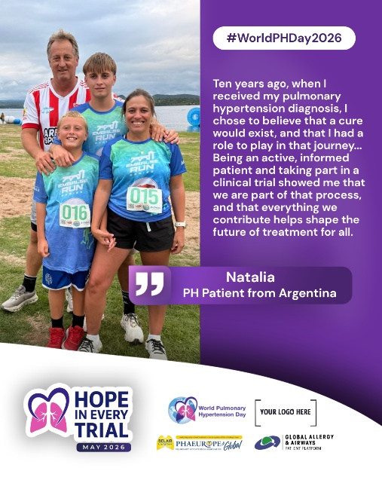
22nd of May |  | Clinical trials bring us closer to better treatments — and for people living with pulmonary hypertension (PH), they represent progress, possibility, and hope.  Every treatment available today exists because patients once chose to take part in research.  Every new trial is a step forward.  🔬 From discovery to approval, it can take years of careful research — from lab studies to Phase I–IV trials involving real patients.  ⏳ This long journey is one of the biggest barriers, especially for those who cannot afford to wait.  Clinical trials:  • Test new treatments and new combinations  • Improve how existing therapies are used  • Explore medical devices and quality of life approaches  • Help shape the future of care for all PH groups  Participation is a personal decision — but it is also a powerful contribution to science and the PH community.  🧠 Every trial follows strict protocols  🛡️ Every study is monitored for safety and ethics  📄 Every participant has the right to full information — and the freedom to withdraw at any time  Because progress depends on people.  Because science needs courage.  Because hope is built step by step, trial by trial. | 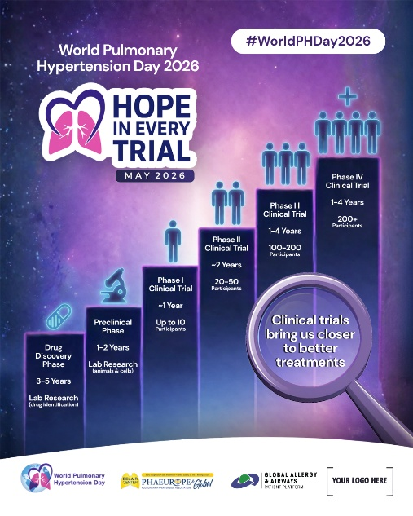
22nd of May |  | Dora │ Hungary  #HopeInEveryTrial  My name is Dora, and I live in Hungary with pulmonary hypertension.  When my doctor told me that existing treatment options were no longer bringing adequate results, participating in a clinical trial felt like a new direction. Only hope for me. It was not a simple decision. Stepping into the unknown never is. But I also knew that clinical trials are conducted in a structured framework, under continuous medical supervision. And that provided me with a sense of security.  Yes, it requires commitment. More frequent visits, more tests, more time. It asks a lot of you. But I made that commitment consciously and willingly. Not only in the hope of improving my own condition, but also because I understood something important along the way: what I contribute today could make these treatments available to others in the future. And with PH, it is always a race against time- clinical trials meant saving time for me, and an opportunity to live.  That thought changed how I saw my participation. It was no longer just about me—it was about every patient who will come after me, who will one day have access to treatments that exist because people chose to take part in research. Thanks to that collective effort, future patients may not have to worry about a lack of options or time.  Clinical trials gave me a new direction when I needed one most. And if my experience can open that same door for someone else, then every extra visit, every extra test, was well worth it."  — Dora, Hungary 💙 | 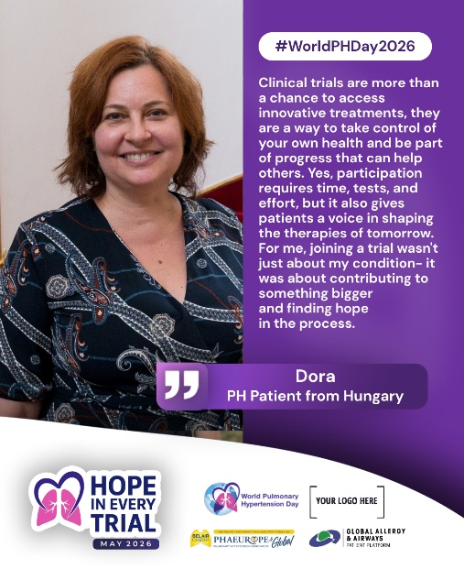
23rd of May |  | This World PH Day 2026 campaign, we highlight a powerful truth:  Hope exists in every clinical trial. For many people living with pulmonary hypertension (PH), even combined therapies are not enough. Clinical trials can offer new treatment possibilities, improved stability, and better quality of life.  🔬 A call to action:  Learn about clinical trials available in your country.  Ask your doctor if you may be eligible to participate. Advocate for clinical trials in your country.  For lungs, and lives, to rise, research must be lifted. More clinical trials mean more hope. And patients play a crucial role in that balance.  In PH, it has always been patients helping patients.  📊 Insights from over 200 PH clinical trials involving 23,000+ participants reveal:  • 68% of participants were women  • 95.6% of trials focused on drug therapies  • 59.5% were industry-sponsored  • 76.3% targeted Group 1 PH (PAH)  • 84.2% were conducted in developed countries  • Children remain significantly underrepresented  But beyond the numbers, a deeper issue remains:  🌍 Clinical trials are not equally accessible worldwide.  Patients in many regions - including parts of Africa, Latin America, Eastern Europe, and Asia, face limited access to trials, fewer specialized centers, and delayed opportunities to benefit from innovation and innovative treatments.  Ethnic and geographic disparities also persist, with underrepresentation of diverse populations in research. This limits how well new treatments reflect real-world patient needs across different backgrounds.  Women and children with PH, in particular, require more targeted, inclusive research.  💜 This is a call for equity.  We need more inclusive, geographically diverse, and accessible clinical trials — so that no matter where a patient lives, they have a fair chance at innovation and care.  Be informed. Ask. Participate. Share.  Because every patient who steps forward helps move us all forward.  Hope is built step by step, trial by trial. | 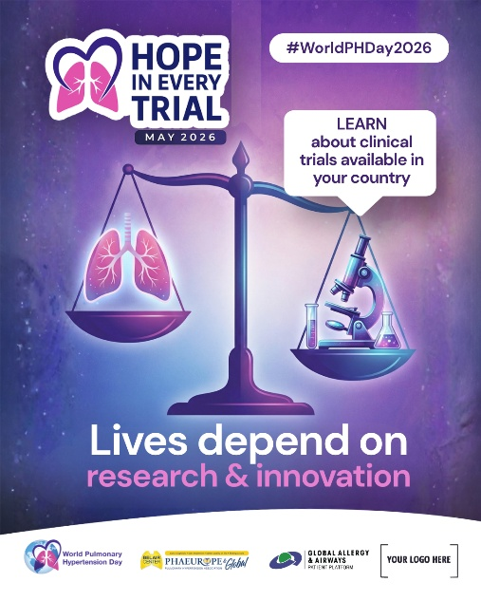
23rd of May |  | Brooke │ Hungary  #HopeInEveryTrial  "My name is Brooke Paulin. I am a pulmonary arterial hypertension patient from Canada, diagnosed in 2014.  Living with PAH means learning to navigate uncertainty every single day. From the moment of diagnosis, your world shifts. Plans become fragile, and hope can sometimes feel distant.  For me, participating in clinical research, or in my case advocating for it, was never just about accessing a new treatment. It was about choosing to be part of something bigger than my own story. Because somewhere out there is a person who will one day benefit from a treatment that exists because patients like us said yes. That thought matters to me deeply.  I also want to be honest: it can feel overwhelming. There are questions, unknowns, and moments of doubt. But I have come to believe that courage is not the absence of uncertainty. It is choosing hope in spite of it.  Hope in Every Trial is not a slogan to me. It is a lived truth. Every study, every participant, every story shared moves us one step closer to better treatments, better outcomes, and one day, a cure.  Hope is not something we wait for. It is something we build, actively, together, one trial at a time."  — Brooke Paulin, Canada 💙 | 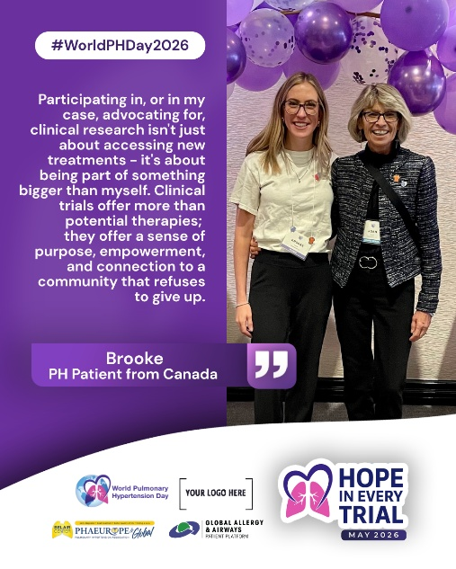
25th of May |  | Gerry │ United States  #HopeInEveryTrial  "My name is Gerry Langan, and I live in Orlando, Florida. Living with pulmonary hypertension has taken me through moments that are emotional, stretching, and at times overwhelming.  Participating in a clinical trial has been one of the most life-changing decisions I’ve ever made. I stepped into it not fully knowing what the outcome would be, and I could never have imagined that I would be here today because of it. What I found along the way was not just progress in my health, stability and new hope, but a profound sense of purpose.  It hasn’t been easy. There were difficult days, moments of uncertainty, and times when everything felt like too much. But through it all, I’ve also experienced something deeply meaningful. This journey has given me a greater gratitude for my health and for the time I have. It has reminded me that even in the hardest seasons, there is purpose.  Being part of something that contributes to better treatments for people living with pulmonary hypertension, and for those who will be diagnosed in the future, means everything to me. It’s bigger than me. And I’m incredibly thankful to play even a small role in moving things forward.  Participating in research is not just about what we go through, but about what we help make possible for others. And that, to me, makes it all worthwhile."  — Gerry Langan, United States 💙 | 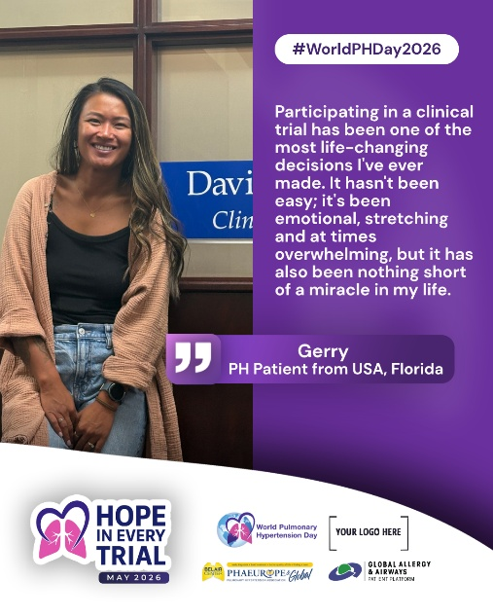
25th of May |  | Manuela │ Austria  #HopeInEveryTrial  "I was diagnosed with rheumatism in 2009, more specifically with scleroderma and Sjögren’s syndrome.  At the beginning of 2016, my health began to deteriorate significantly. My shortness of breath became increasingly severe and was accompanied by physical weakness. After a very long hospital stay, I was eventually referred to the pulmonary outpatient clinic at the University Hospital in Graz. There, following a right heart catheterization, I was diagnosed with pulmonary arterial hypertension.  I was then prescribed an approved medication (combination therapy) and was also enrolled in a clinical study. At first, I was very skeptical – it was a new medication that was not yet widely used and for which there was not yet extensive long-term experience. Nevertheless, I decided to stay positive and give it a try.  After some time, I began to notice initial improvements, and eventually, it became clear that the medication was very effective. I continue to take it to this day and now receive it regularly on prescription.  At present, I am doing very well, and I am incredibly grateful for this development and outcome. I am especially thankful that I was accepted into the study at that time.  My sincere thanks go to the entire pulmonology team in Graz, who have accompanied and supported me on this journey - and continue to do so."  — Manuela, Austria 💙 | 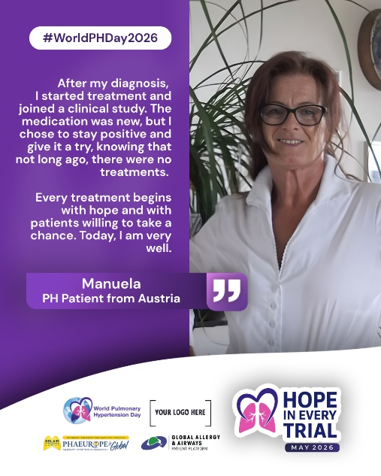
26th of May |  | Vera │ Bosnia and Herzegovina  #HopeInEveryTrial  "My name is Vera Hodžić. I am 64 years old, and I have been living with pulmonary hypertension since 2013. From the moment I was diagnosed, I was faced with the reality that in Bosnia and Herzegovina, I had to purchase extremely expensive medications myself. That is when my fight began - not only for myself, but for all PH patients in my country.  I founded the Association of Pulmonary Hypertension Patients “DAH” (Breath) in Bosnia and Herzegovina, and since then, I have been fighting a battle that often feels like a battle with windmills. Over the past 13 years, we have brought together around 100 patients. Sadly, some of them are no longer with us, having never had the chance to access better treatment, benefits of clinical trials, or improved care.  We cannot bring back the lives lost, but we can continue to fight for better access to research. In Bosnia and Herzegovina, opportunities for clinical trials have been extremely limited. Our patients had the chance to participate in studies more than a decade ago, and since then, very little has changed. Meanwhile, neighboring countries have opened doors to innovative therapies, sometimes even for our patients. We are grateful for these opportunities, but for someone living with PH, traveling abroad for examinations, detailed test, and treatment is exhausting, difficult, and financially demanding.  I believe that change is possible. I hope that stronger collaboration between institutions, doctors, and the pharmaceutical community will bring clinical trials to Bosnia and Herzegovina. Our patients deserve to be recognized and supported equally, just like all PH patients across Europe and the world. The need exists. The patients exist. The treatments exist. What we need is organization, understanding, empathy, and the will to act.  My message is simple: we must not be left behind. Every patient deserves a chance for a better and longer life through access to research and new therapies.  My fight will last until my last breath - hope dies last."  — Vera Hodžić, Bosnia and Herzegovina 💙 | 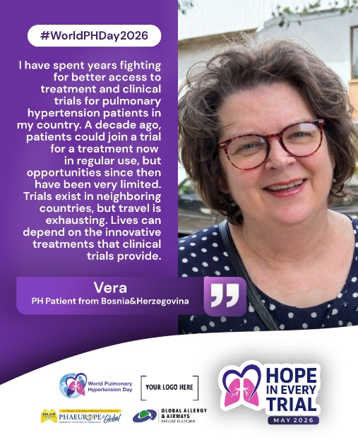
26th of May |  | Dušanka │ Serbia  #HopeInEveryTrial  “Always consider all available paths toward a better quality of life. Clinical trials saved my life”  "My name is Dušanka Radojičić. I am 70 years old and I live in Serbia.  My journey with pulmonary hypertension changed direction after I collapsed in the street and suddenly found myself in a situation where my body was no longer responding the way it used to, and my condition was deteriorating. That moment led to further examinations and, eventually, I was invited to take part in a clinical trial involving a newer group of PH therapy - something that promised a new chance at life. The opportunity alone already felt like a meaningful step forward.  What followed required time and commitment. For six months, my days were often spent between hospital visits, diagnostics, and blood tests - sometimes lasting six or seven hours. It was demanding, both physically and in terms of endurance and patience.  During that period, I was also given different perspectives from medical professionals around me, some suggesting I carefully consider my options before proceeding. Still, I felt calm in my decision. Reassured by other experts I made an informed decision considering the alternative. Something in me said to continue, step by step, and I did.  Today, I feel significantly better. In a way I never thought possible, my condition has improved to the point where daily life feels lighter and more open again. It feels as though pulmonary hypertension no longer defines every part of my day.  What I want to share with others is simple: I would choose this path again. It has made a meaningful difference in my life.  Clinical trials open doors to new possibilities. They provide close monitoring, structured care, and the chance to contribute to progress while receiving treatment that may not otherwise be available on top od your regular therapy. I encourage others to stay open, to ask questions, and to consider all available paths toward a better quality of life.  For me, it changed everything."  — Dušanka Radojičić, Serbia 💙 | 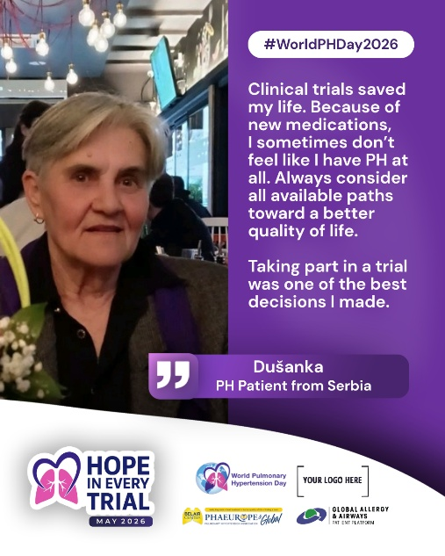
27th of May |  | Katiusca │ Venezuela  #HopeInEveryTrial  “My story is one of resilience - but resilience should not have to fill in all the gaps.”  "My name is Katiusca Salinas. I am 56 years old. I am a professional, a daughter, sister, wife, and mother of two children who are now adults and my greatest pride. Since 2017, my life has also been marked by pulmonary hypertension.  It all began one December, when an unexplained exhaustion took over my body. It was not ordinary tiredness - I could barely take a step. I had to leave my job because even the simplest daily responsibilities became impossible. At first, I was told it might be depression, but my condition continued to worsen.  Everything changed when a cardiologist looked at me and said clearly that what I was experiencing was a pulmonary hypertension crisis. In my confusion, I tried to correct her, thinking it was related to blood pressure, until I was referred to a specialist and underwent further tests. That is when idiopathic pulmonary hypertension was confirmed.  I started treatment, and for the first time in a long while, I felt my breathing open again. There was a sense of relief I had almost forgotten. But what followed was something I had not expected: that improvement was never stable, because access to therapy itself became unstable.  Over time, the reality in Venezuela became very clear to me and to many others like me. Treatments that once formed the backbone of care began to disappear or arrive inconsistently. Combination therapy, which many patients elsewhere consider standard, became something we could only hear about, not actually experience. We were often left with only fragments of what a full treatment plan should be.  There were moments when medication was simply not available, and other times when it depended on long waiting periods or uncertain supply channels. Each time, you learn to adjust your life around what is or is not there, rather than around what you actually need.  In Venezuela, living with pulmonary hypertension means living with interruptions that shape everything- your energy, your plans, your independence. Clinical trials and studies are also not an option here, which makes it even harder to access newer therapies that could offer stability.  Still, I hold on to the periods when treatment was available, because they showed me what is possible. They are proof that breathing easier is not an abstract idea - it is something real when care is continuous.  My message is simple: we are not statistics. We are people trying to keep our lives together under very unstable conditions. We need continuity, we need access, and we need the possibility to be part of progress, not outside of it.  My story is one of resilience - but resilience should not have to fill in all the gaps."  — Katiusca Salinas, Venezuela 💙 | 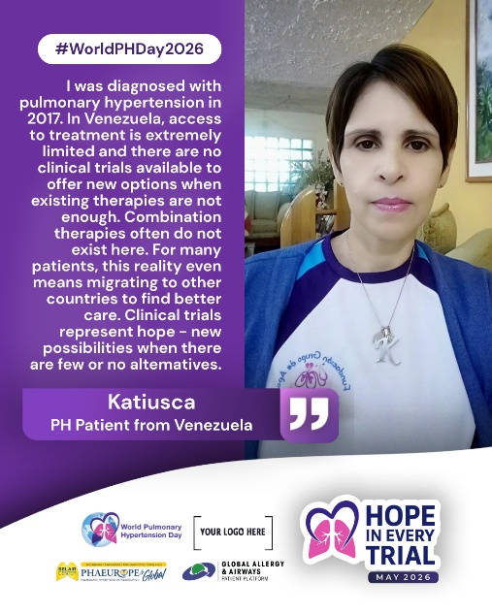
28th of May |  | Huang Huan │ China  #HopeInEveryTrial  "My name is Huang Huan. I am from China and living with pulmonary hypertension.  For many patients here, access to clear and reliable information about clinical trials is still limited. This becomes even more difficult for those living in rural areas or far from specialized pulmonary hypertension centers, where opportunities for timely guidance and structured support are not always available. Because of this, many patients are not fully aware of what clinical research involves, or what options they may have.  There is also another layer of difficulty when it comes to international clinical trials. Some studies require patients to already be on stable background therapy at specific doses before they can be included. In everyday clinical practice, however, treatment approaches may differ, and medications are sometimes used at lower doses. This can unintentionally exclude patients who might otherwise be eligible to participate.  At the same time, the experience of patients has not always been fully reflected in how trials are designed. Study materials and follow-up questionnaires are often not adapted to local language nuances or cultural context, which can make it harder for patients to fully engage or express their experience.  Despite these challenges, I believe there is real value in bringing patient perspectives into focus. When patients are informed, supported, and included in a way that reflects their reality, clinical research becomes more accessible and more meaningful for everyone involved.  I am grateful for the opportunity to share this perspective and to help highlight the situation for patients in China. I hope it contributes to greater understanding and more inclusive approaches in future research."  — Huang Huan, China 💙 | 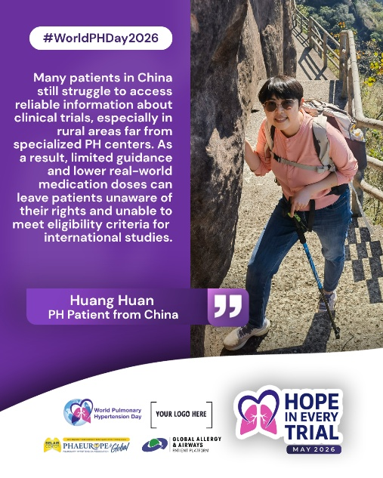
29th of May | ENDING  ONLY PHAE | A heartfelt thank you to everyone who came together to raise awareness for pulmonary hypertension on #WorldPHDay2026.  To every PH patient around the world who shared their story of participating in clinical trials, and to those advocating for more inclusive and accessible research, clinical trials and studies - your voices shaped this campaign and gave it meaning.  Your support is a powerful force, amplifying the voice of the global PH community.  Your voice gives meaning to this years slogan – Hope in Every Trials, as it is you who transcend trials by being courageous and participating in clinical trials and bringing hope to all.  By sharing your experiences, you are doing more than telling your story - you are guiding others. You are helping fellow patients feel less alone, more informed, and more empowered to take part in their own journey.  Because every story shared is a step toward better quality of life, better outcomes,  and ultimately - a cure.  Your experiences inspire others to take part, to ask questions, and to become part of progress.  Thank you for reminding us that progress depends on people, that science needs courage, and that hope is built step by step, trial by trial. | 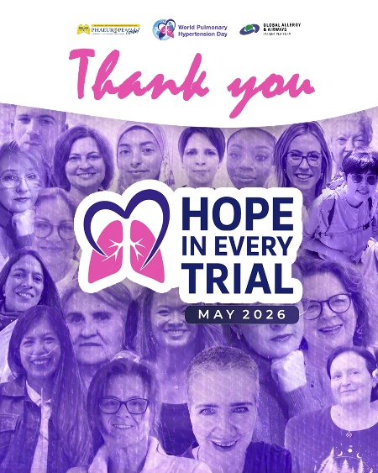
30th of May | ENDING  ONLY PHAE | 💜 Thank You to our industry partners and sponsors🙏  The success of World Pulmonary Hypertension Day 2026 would not have been possible without the generous support of our sponsors and industry partners. Your commitment to supporting our patient association drives progress, and your investment in clinical trials brings us closer to new possibilities and renewed hope.  Your partnership helps unite patients, caregivers, and healthcare professionals—fostering knowledge, strengthening connections, and inspiring hope across the pulmonary hypertension community.  Hope is built step by step, trial by trial. | 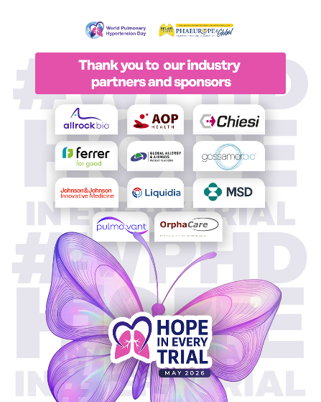
30th of May | ENDING  ONLY PHAE | 💜 Thank you to the global PH community and members of PHAEUROPE🙏  World Pulmonary Hypertension Day is a global initiative uniting PH patients, associations, organisations, and people around the world. This day is dedicated to the global PH community, and PHAEUROPE is grateful to individuals, PH patients, and PHighters for standing alongside us during World PH Day 2026 and for sharing experiences that move us forward. 💙🙏  PHAEUROPE remains firmly committed to its mission of supporting PH associations and empowering patients across the globe. 💪 | 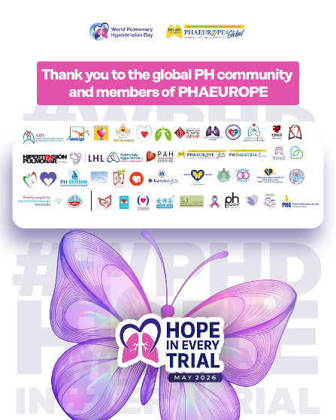
COVERS | Alternative | 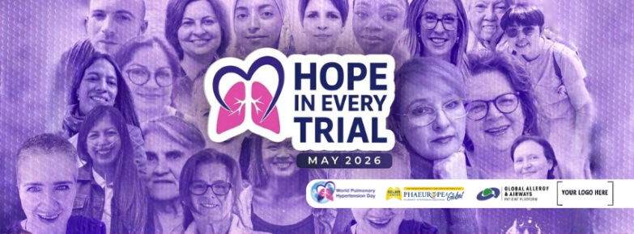  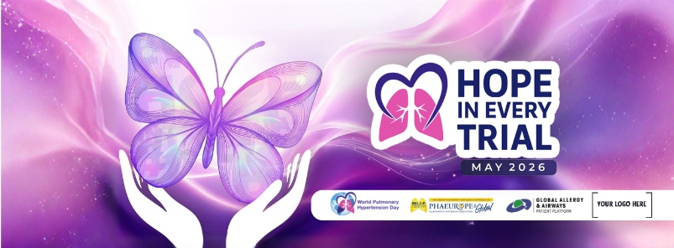  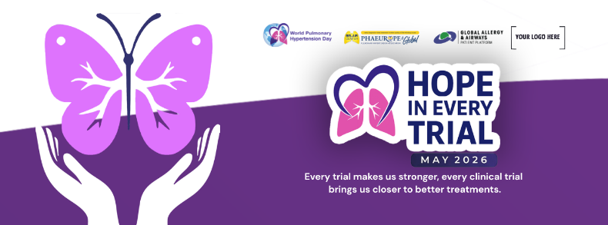 | /

- INFOGRAPHICS EDITABLE CANVA TEMPLATES - LINK
- PATIENT TESTIMONIALS EDITABLE CANVA TEMPLATES - LINK
- BANNERS EDITABLE CANVA TEMPLATES -LINK

Hashtags: #WorldPHDay2026 #HopeInEveryTrial #WPHD #PHAEurope #pulmonaryhypertension #awareness #patientcare #patientempowerment #CTEPH #PAH #ClinicalTrials #PHAwareness #pulmonaryarterialhypertension
Links to use in posts: ➡www. worldphday.org ➡www.phaeurope.org ➡belaircenter.info

